Cloning F:\PhasedArray\PAP into F:\Play-Git

**Start in the target folder.**

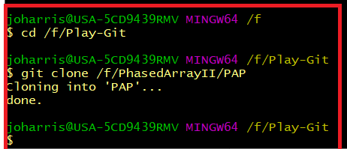

**The argument for the clone operation is the source of the clone.**

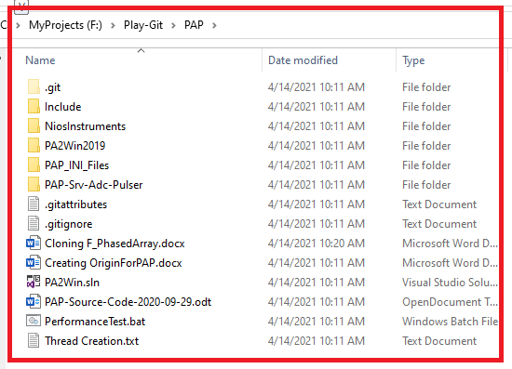

**The source file for the clone is F:\PhasedArray\PAP**

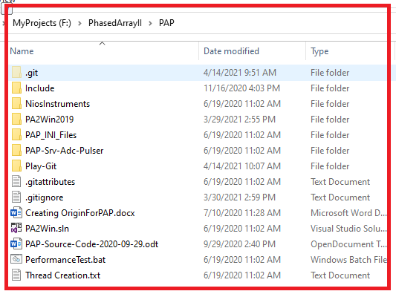

Run git status to see if branches need to be merged in the Play-Git repo version.

